*Temporal Trends and Severity of Weak Authentication Vulnerabilities: A Statistical Approach(*1st Draft*)*

Kishan Karthik S  
*Computer Science and Engineering,*

*(Cyber Security)*

*RV College of Engineering®*

*Bengaluru, India*

Suraj Singh  
*Computer Science and Engineering,*

*(Cyber Security)*

*RV College of Engineering®*

*Bengaluru, India*

Varshith Y  
*Computer Science and Engineering,*

*(Cyber Security)*

*RV College of Engineering®*

*Bengaluru, India*

***Abstract*—In the rapidly evolving landscape of cybersecurity, vulnerabilities related to weak authentication mechanisms present significant threats to organizational security. This study provides a comprehensive analysis of high-threat vulnerabilities associated with weak authentication, focusing on their frequency, severity, and temporal trends. Leveraging a dataset of reported vulnerabilities, we employ statistical methods to evaluate the prevalence and impact of these security issues. Our findings highlight critical areas where authentication mechanisms are particularly vulnerable, offering insights into the evolution of these threats over time. This research aims to inform better risk management strategies and support the development of more robust authentication protocols to mitigate these vulnerabilities effectively.**

***Keywords—Weak Authentication, Cybersecurity, Vulnerability Analysis, Risk Management, Statistical Evaluation, Temporal Trends, Data Breaches, Mitigation Strategies.***

# I. Introduction

In the current digital age, cybersecurity remains a paramount concern as the frequency and sophistication of cyber-attacks continue to escalate. Among various cybersecurity threats, vulnerabilities related to weak authentication mechanisms pose significant risks, often leading to severe consequences such as data breaches and unauthorized access. This research paper aims to delve into the analysis of high-threat vulnerabilities associated with weak authentication and their impact on overall system security.

The study employs a comprehensive approach to identify and categorize vulnerabilities, leveraging statistical methods to evaluate their frequency and severity. By examining temporal trends, this research provides insights into how the nature of these vulnerabilities has evolved over time, thereby informing strategies for effective risk management and mitigation. This research significantly impacts the field by offering valuable insights for researchers and practitioners, serving as a foundation for further exploration and the development of new methodologies and tools for vulnerability detection and prevention.

This research contributes to the field by enhancing the understanding of weak authentication vulnerabilities and supporting the development of more robust security measures.

# II. Model Inference

This comprehensive report analyzes various machine learning models applied to a dataset of security vulnerabilities to uncover underlying patterns and predict severity and classification. The models evaluated include Linear Regression, Decision Tree Regression, Random Forest Regression, Logistic Regression, Decision Tree Classification, Random Forest Classification, Support Vector Classification (SVC), and K-Nearest Neighbors (KNN).

**Linear Regression:** Linear Regression attempts to predict CVSS (Common Vulnerability Scoring System) scores based on dataset features. The model achieves a Mean Squared Error (MSE) of 3.102, indicating moderate accuracy in capturing linear relationships but significant variance.

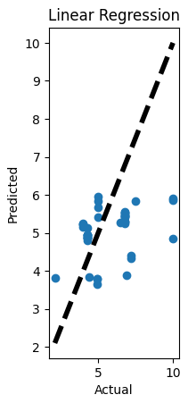

**Decision Tree Regression:** In contrast, Decision Tree Regression excels at identifying non-linear patterns, achieving an MSE of 0.0507. This demonstrates superior performance compared to Linear Regression, effectively capturing complex feature interactions.

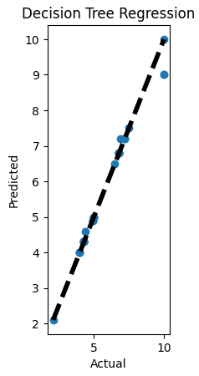

**Random Forest Regression:** Utilizing ensemble learning, Random Forest Regression achieves an MSE of 0.1094, balancing bias and variance better than Linear Regression. It proves adept at handling intricate feature interactions for improved generalization.

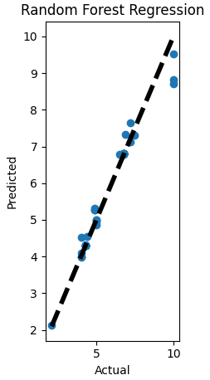

* **Logistic Regression:** Focused on classifying vulnerabilities by CWE (Common Weakness Enumeration) code, Logistic Regression achieves an accuracy of 66.67%. However, convergence issues suggest potential complexity or need for further model refinement.

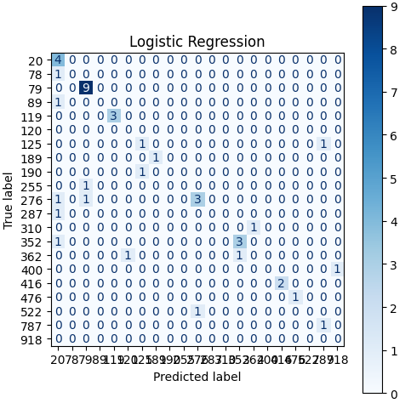

**Decision Tree Classification:** Among classification models, Decision Tree Classification stands out with an accuracy of 78.57%, effectively capturing relationships between features and CWE codes, indicating strong predictive capability.

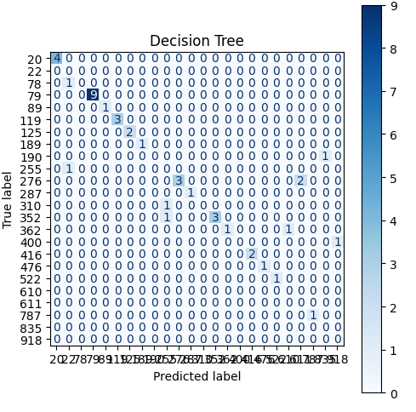

**Random Forest Classification:** Similar to its regression counterpart, Random Forest Classification combines multiple decision trees to achieve an accuracy of 69.05%. This model offers robust performance in classification tasks, balancing bias and variance effectively.

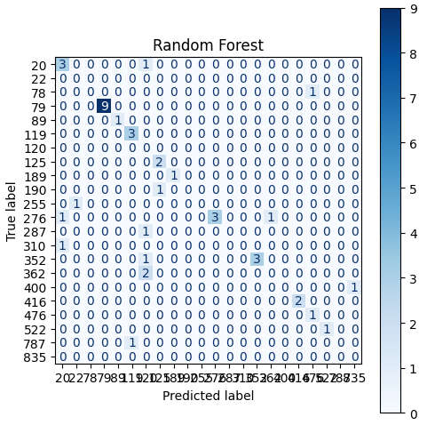

**Support Vector Classification (SVC):** SVC shows a lower accuracy of 21.43%, indicating challenges in classifying vulnerabilities in this dataset. Further optimization or feature engineering may be necessary to enhance performance.

### 

1. **K-Nearest Neighbors (KNN) Classification:** KNN achieves an accuracy of 66.67%, comparable to Logistic Regression, showing moderate effectiveness in capturing local patterns. Adjustments to neighbor count may improve accuracy in future iterations.

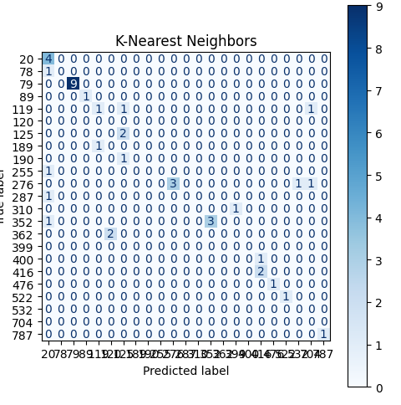

Key Insights from Combined Analysis:

Non-Linear Relationships: Decision Tree models and Random Forest models consistently outperform Linear Regression, highlighting the importance of non-linear relationships in predicting vulnerability severity.

Importance of Feature Engineering: The performance of the models, especially SVC, suggests that feature engineering might be necessary to improve accuracy. This involves creating new features or transforming existing ones to better represent the data's inherent characteristics.

**CWE as a Significant Indicator:** The classification models, particularly the Decision Tree, demonstrate that CWE code is a significant predictor of vulnerability type. This further emphasizes the importance of understanding CWE categories in vulnerability analysis.

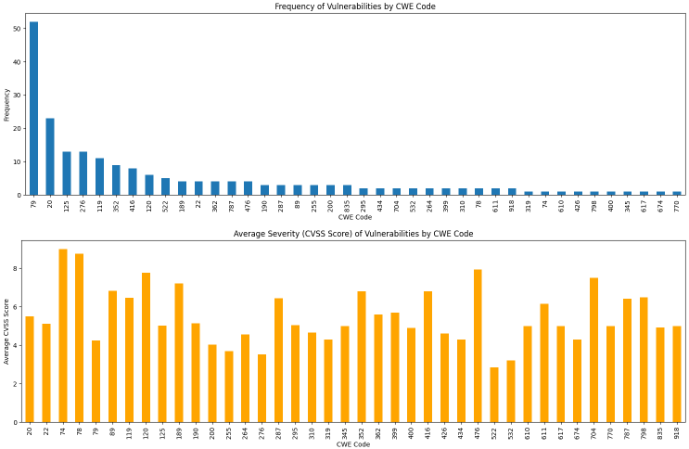

**Feature Engineering:** Exploring feature engineering techniques to improve model accuracy. This might involve incorporating additional features, transforming existing ones, or applying dimensionality reduction methods.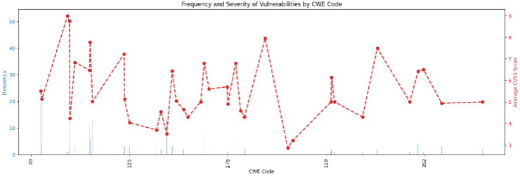

**Ensemble Methods:** Leveraging ensemble methods, like Random Forest, for their robustness and generalization capabilities.

**Domain Expertise:** Combining model insights with domain expertise to gain deeper understanding of vulnerability patterns. This could involve working with security professionals to interpret results and make informed decisions

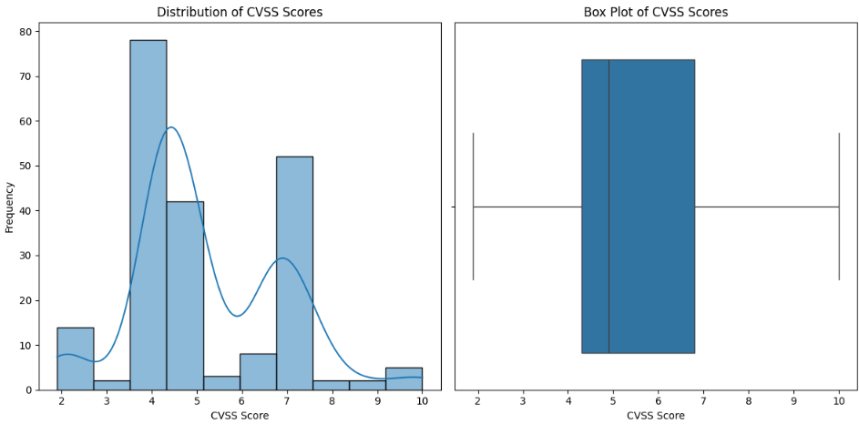

### III. Trend of the top 10 prevalent attacks over the years

## **Cross-Site Scripting (XSS)**

* **Description:** An attacker injects malicious scripts into web pages viewed by other users.
* **Underlying Issue:** Poor input validation and escaping of user-supplied data.
* **Example:** An attacker injects a script in a comment section, which executes when viewed by others.

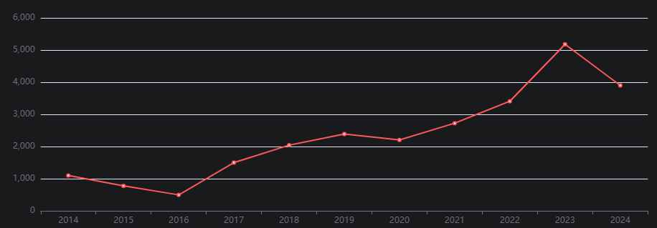

### **Trends and Real-Life Scenarios Impacting Vulnerability Trends**

* **Rise and Fall:** The prevalence of XSS attacks surged alongside the rise of dynamic web applications and increased user-generated content. As developers began to prioritize features over security, vulnerabilities proliferated. However, the implementation of secure coding practices, frameworks that offer built-in protections, and the growing awareness of web security have led to a significant decline in successful XSS attacks.
* **Real-Life Impact:** High-profile attacks on major social media platforms have brought the issue to the forefront, leading to improved security measures and user awareness. Events such as the MySpace Samy worm demonstrated the potential for XSS to spread virally, prompting platforms to invest in robust mitigation strategies.

## **SQL Injection**

* **Description:** An attacker inserts or "injects" malicious SQL queries via input fields.
* **Underlying Issue:** Improper handling of user inputs in SQL queries.
* **Example:** An attacker enters SQL commands in a login form to bypass authentication.

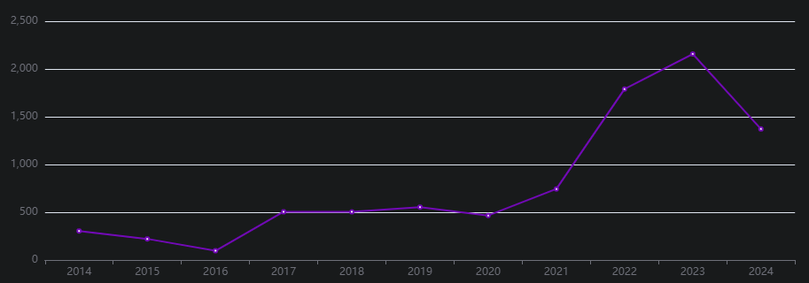

### 

### 

### **Trends and Real-Life Scenarios Impacting Vulnerability Trends**

* **Rise and Fall:** SQL Injection was rampant in the early days of web development due to insufficient input sanitization practices. As web developers adopted prepared statements and Object-Relational Mapping (ORM) frameworks, the frequency of these attacks saw a notable decline. Despite this, SQL Injection remains a top concern due to legacy systems that still employ vulnerable coding practices.
* **Real-Life Impact:** Major breaches, like the 2013 Adobe incident, where attackers exploited SQL Injection vulnerabilities to access sensitive user data, underscored the necessity for secure database interactions. The aftermath of these breaches has led organizations to reevaluate their database security measures, resulting in heightened focus on secure coding practices.

## **Buffer Overflow**

* **Description:** An attacker exploits a buffer overflow to execute arbitrary code.
* **Underlying Issue:** Writing more data to a buffer than it can hold**.**
* **Example:** An attacker exploits a vulnerable function to execute malicious code.

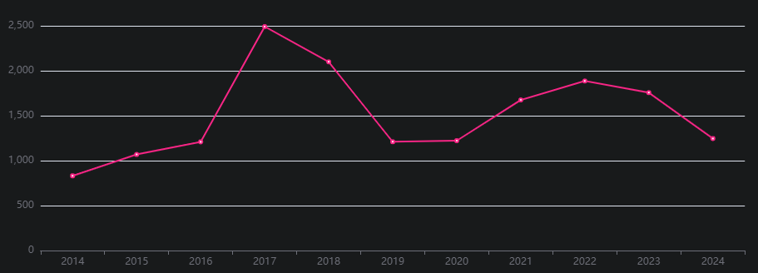

### **Trends and Real-Life Scenarios Impacting Vulnerability Trends**

* **Rise and Fall:** Buffer overflow vulnerabilities were widespread in older software, particularly those written in C and C++, due to their inherent memory management flaws. The decline in these attacks can be attributed to the adoption of modern programming languages that enforce better memory safety practices, reducing the potential for such vulnerabilities.
* **Real-Life Impact:** Incidents like the Morris Worm in 1988 demonstrated the catastrophic effects of buffer overflows, prompting a significant shift in how developers approached security. This historical context has fostered a culture of vigilance, leading to the implementation ofstricter coding standards and more robust security testing methodologies.

## 

## **Denial of Service (DoS)**

* **Description:** An attacker floods a system with requests, causing it to become unavailable.
* **Underlying Issue:** Excessive resource consumption by malformed or excessive requests.
* **Example:** Botnets launching a massive number of requests to a server.

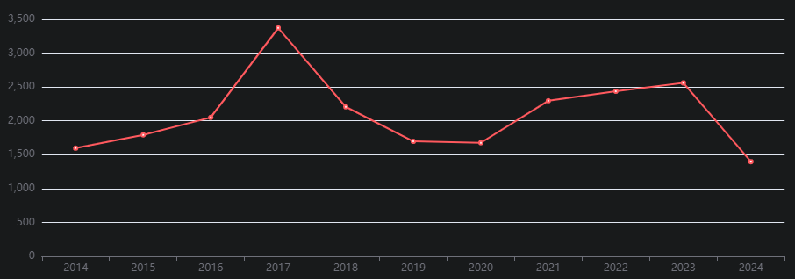

### **Trends and Real-Life Scenarios Impacting Vulnerability Trends**

* **Rise and Fall:** DoS attacks have increased in frequency with the expansion of the internet and the proliferation of tools that simplify launching such attacks. While the overall number of attacks has risen, advancements in defensive strategies—such as rate limiting, traffic filtering, and better infrastructure resilience—have contributed to a decline in their effectiveness.
* **Real-Life Impact:** Major incidents, like the 2016 Dyn attack, which disrupted a significant portion of the internet by targeting DNS services, highlighted the vulnerabilities within critical infrastructure. These events have prompted organizations to invest heavily in DoS mitigation technologies and awareness campaigns to bolster their defenses.

## **Code Execution**

* **Description:** An attacker executes arbitrary code on a target system.
* **Underlying Issue:** Exploiting vulnerabilities like buffer overflows or unpatched software.
* **Example:** Malware exploiting a software vulnerability to run malicious code.

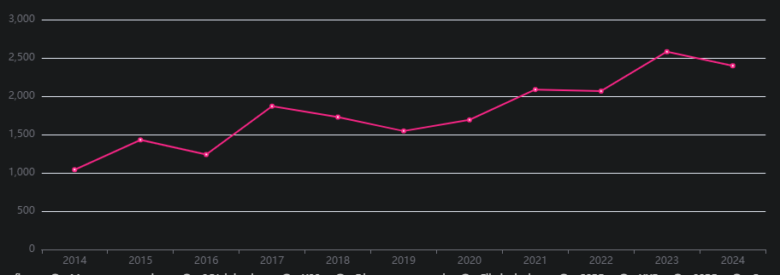

### 

### **Trends and Real-Life Scenarios Impacting Vulnerability Trends**

* **Rise and Fall:** Code execution vulnerabilities remain a significant threat, driven by the continuous discovery of software flaws. Despite the decline in some specific vulnerabilities due to regular patching and improved security practices, the emergence of sophisticated malware ensures that code execution remains a pressing concern.
* **Real-Life Impact:** Incidents like the Stuxnet attack illustrated the potential for code execution to be weaponized in cyber warfare, raising awareness among governments and corporations alike. This has led to increased investment in cybersecurity measures and a more proactive approach to vulnerability management.

## **Directory Traversal**

* **Description:** An attacker accesses restricted directories and files.
* **Underlying Issue:** Improper validation of user input paths.
* **Example:** An attacker uses ../ to access system files outside the web root.

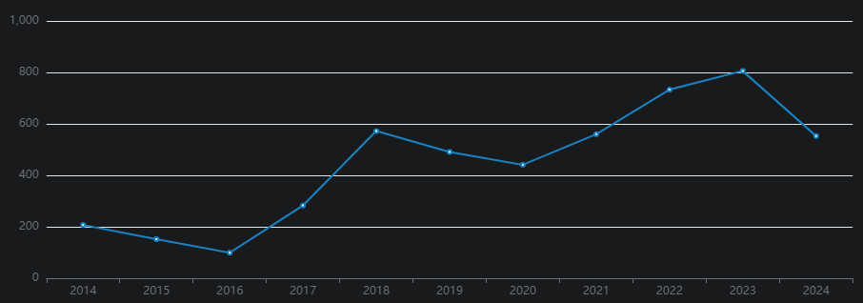

### **Trends and Real-Life Scenarios Impacting Vulnerability Trends**

* **Rise and Fall:** Directory traversal attacks were common in the early days of web applications, where developers often overlooked input validation. As frameworks and best practices evolved, the incidence of such attacks declined significantly. However, legacy applications still pose risks, necessitating ongoing vigilance.
* **Real-Life Impact:** Early attacks on web servers emphasized the importance of proper input **sanitization.** High-profile breaches stemming from directory traversal vulnerabilities have led organizations to adopt comprehensive security policies and training to prevent similar occurrences**.**

**Cross-Site Request Forgery (CSRF)**

* **Description:** An attacker tricks a user into executing unwanted actions.
* **Underlying Issue:** Lack of anti-CSRF tokens and proper session handling.
* **Example:** An attacker tricks a user into submitting a form that changes their email.

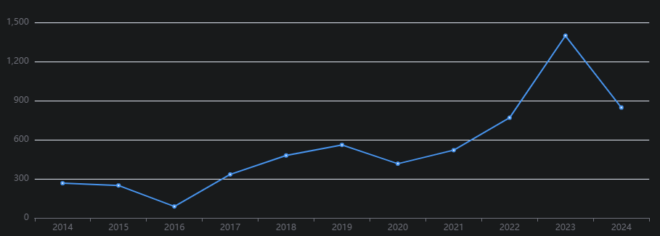

### 

### **Trends and Real-Life Scenarios Impacting Vulnerability Trends**

* **Rise and Fall:** CSRF attacks gained traction with the growing reliance on user sessions in web applications. The subsequent decline can be attributed to the widespread implementation of anti-CSRF tokens and improved session management techniques that protect against such exploits.
* **Real-Life Impact:** Attacks on banking and e-commerce websites highlighted the critical need for protective measures against CSRF, leading to stricter regulations and industry standards. This awareness has fostered a more security-conscious development culture, prioritizing user safety.

## **Privilege Escalation**

* **Description:** An attacker gains higher privileges than intended.
* **Underlying Issue:** Vulnerabilities in software that allow bypassing permission checks.
* **Example:** An attacker exploits a flaw to gain administrative access.

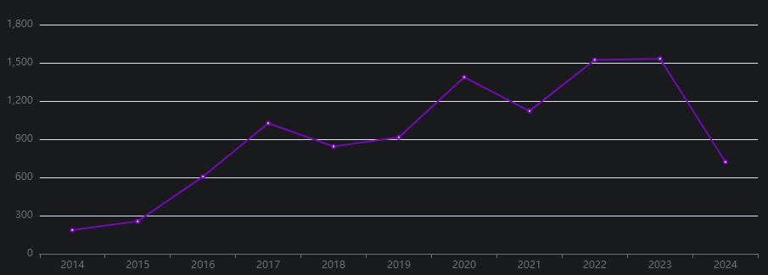

### **Trends and Real-Life Scenarios Impacting Vulnerability Trends**

* Rise and Fall: Privilege escalation vulnerabilities have persisted due to consistent flaws in permission handling across software systems. While improvements in access control mechanisms have led to a decline in some instances, new vulnerabilities continue to emerge, underscoring the ongoing challenge.
* **Real-Life Impact:** High-profile exploits in operating systems, such as Windows and Linux, have brought significant attention to the risks associated with privilege escalation. These incidents have prompted software vendors to implement more robust permission checks and user role management practices.

## **Information Disclosure**

* **Description:** An attacker gains access to sensitive information**.**
* **Underlying Issue:** Inadequate access controls and information leakage.
* **Example:** Error messages revealing database structure.

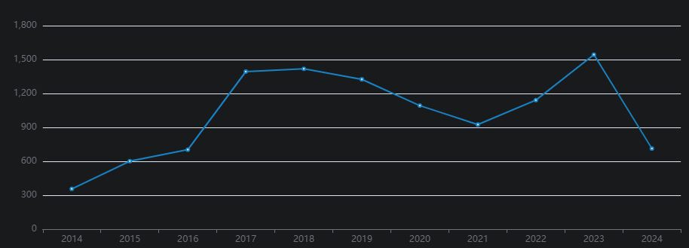

### **Trends and Real-Life Scenarios Impacting Vulnerability Trends**

* **Rise and Fall:** Information disclosure vulnerabilities have surged with the increasing complexity of web applications and their error handling processes. The decline in such incidents can be linked to better information hiding practices and the adoption of privacy regulations that emphasize data protection.
* **Real-Life Impact:** Data breaches, such as the Equifax breach, have highlighted the need for organizations to safeguard sensitive information. The aftermath of these breaches has led to stricter compliance requirements and a renewed focus on security training for developers.

## 

## 

## **Security Misconfiguration**

* **Description:**Misconfigured settings leading to vulnerabilities.
* **Underlying Issue:** Default configurations, incomplete configurations, and unpatched systems**.**
* **Example:** Default admin accounts or open ports.

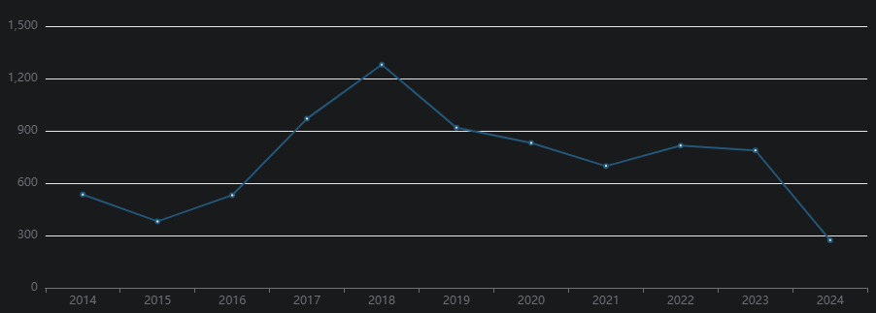

### **Trends and Real-Life Scenarios Impacting Vulnerability Trends**

* **Rise and Fall:** Security misconfigurations have remained prevalent due to the complexity of securely configuring systems. However, the decline in successful attacks can be attributed to the development of better security tools and practices that help organizations maintain secure environments.
* **Real-Life Impact:** Incidents involving cloud misconfigurations, like the Capital One breach, have underscored the critical need for secure configurations. These events have prompted organizations to adopt comprehensive security frameworks and regular audits to prevent similar vulnerabilities.

**——————————————————————————————————————-**

### **Vulnerability Pattern Analysis**

### **1. XSS and SQL Injection**

#### **Inter-relations/Dependencies:**

Both XSS and SQL injection vulnerabilities frequently arise from inadequate input validation and sanitization. Historically, incidents such as the 2008 Facebook XSS vulnerability highlighted how attackers could manipulate user sessions, leading to subsequent SQL injection exploits. When an attacker leverages XSS to steal session tokens, they may then exploit SQL injection vulnerabilities to access sensitive data.

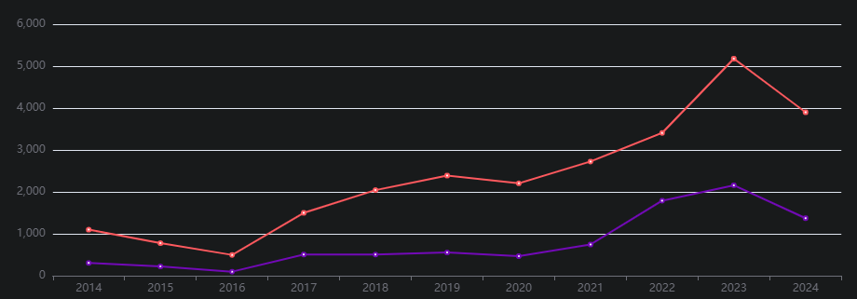

#### **Precautions to Be Taken Based on Lessons Learned:**

To mitigate these risks, organizations should implement strict input validation and employ prepared statements for database queries. Additionally, adopting secure coding practices and using frameworks that provide built-in protection against these vulnerabilities can significantly reduce exposure.

### **2. Buffer Overflow and Denial of Service**

#### **Inter-relations/Dependencies:**

Buffer overflow vulnerabilities were notably prevalent in the late 1990s and early 2000s, contributing to high-profile attacks such as the Code Red worm, which caused widespread DoS. Exploiting a buffer overflow can lead to system crashes, directly resulting in Denial of Service incidents. For example, the 1988 Morris Worm demonstrated how buffer overflows could disrupt network services.

#### 

#### **Precautions to Be Taken Based on Lessons Learned:**

To prevent these issues, developers should employ bounds checking and utilize modern programming languages that offer built-in memory safety features. Regular patching and updates can also help mitigate vulnerabilities associated with buffer overflows.

### **3. Code Execution and Directory Traversal**

#### **Inter-relations/Dependencies:**

Directory traversal attacks have historically been leveraged to gain access to sensitive files, often leading to arbitrary code execution. Notable breaches, such as the 2009 Heartland Payment Systems incident, exemplify this dependency. When attackers exploit directory traversal, they may access configuration files that facilitate code execution.

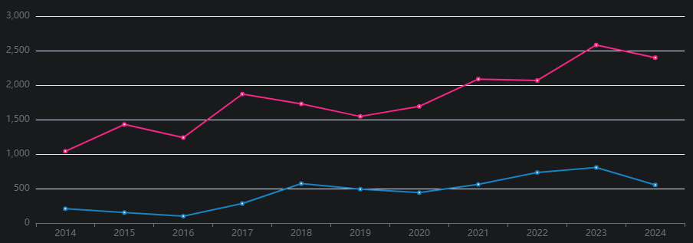

#### **Precautions to Be Taken Based on Lessons Learned:**

To defend against these vulnerabilities, organizations must enforce strict access controls and adhere to secure coding practices. Regularly auditing code for vulnerabilities and employing security tools to detect directory traversal weaknesses can help prevent exploitation.

### **4. CSRF and Privilege Escalation**

#### **Inter-relations/Dependencies:**

Cross-Site Request Forgery (CSRF) attacks have been a persistent threat since the rise of web applications. In 2010, a CSRF vulnerability allowed attackers to escalate privileges on PayPal accounts. Successful CSRF attacks can lead to unauthorized actions that potentially escalate privileges within an application, as demonstrated in the 2011 GitHub incident.

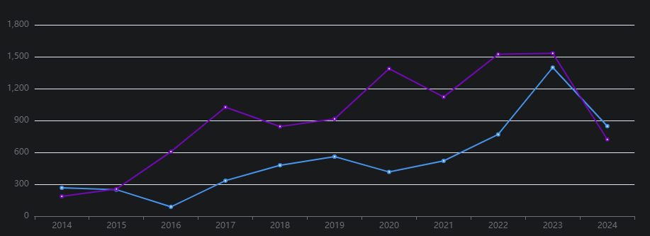

#### **Precautions to Be Taken Based on Lessons Learned:**

To mitigate the risks associated with CSRF and privilege escalation, it is essential to implement anti-CSRF tokens and maintain robust session management practices. Regular security reviews and testing can helpidentify and address vulnerabilities in session handling.

### **5. Information Disclosure and Security Misconfiguration**

#### **Inter-relations/Dependencies:**

Security misconfigurations have consistently led to significant information disclosure incidents. The 2019 Capital One breach, caused by a misconfigured firewall, exposed personal data of over 100 million customers. Similarly, inadequate access controls often result in the unintentional exposure of sensitive information.

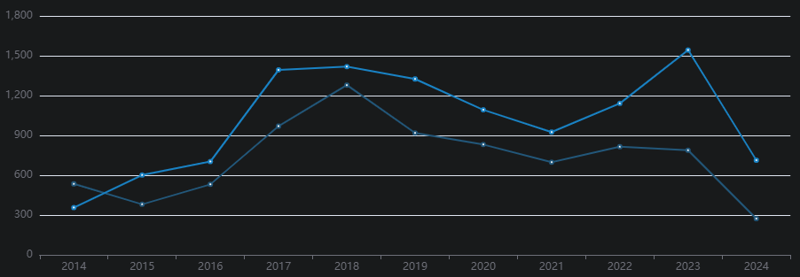

#### **Precautions to Be Taken Based on Lessons Learned:**

Organizations should regularly review their configurations and enforce security best practices to prevent information leakage. Conducting security audits, using automated tools for configuration management, and ensuring that default settings are changed can greatly enhance security posture.

This format provides a comprehensive overview of inter-relations between attacks, emphasizing historical context and actionable precautions to be taken based on lessons learned.

### **Conclusion**

The evolution of vulnerabilities over the years has been shaped by technological advancements, shifts in security practices, and significant incidents that heightened awareness. By analyzing the root causes and real-world impacts of these vulnerabilities, we can develop more effective security measures that mitigate risks and enhance overall resilience against exploitation. This understanding is crucial for fostering a proactive security posture and safeguarding against emerging threats.

Moreover, continuous education and adaptation are essential as the threat landscape evolves. Organizations must invest in regular security assessments, employee training, and the adoption of industry best practices to stay ahead of potential vulnerabilities. Ultimately, a comprehensive approach that integrates lessons learned from past incidents will strengthen defenses and contribute to a more secure digital environment.